DAA Lab-3

Name: Kshitij Kumar Sharma Roll No.: 1905514 Date: 29/07/2021

**Q1)** Write a program to sort a given set of elements using the insertion sort. Additionally, determine the time required (in terms of steps) to sort the elements.

(Note: assume cost of any basic operation is 1, i.e., c1= c2 = ... = c8 = 1).

1) Repeat the experiment for different values of n = 500, 1000, 5000, 10000

2) For each of aforementioned case, consider arrays as sorted, random, and reverse-sorted. Provide the complexity in terms of step count

Program:

/*

Written by: Kshitij Kumar Sharma Roll No: 1905514

Question:

Write a program to sort a given set of elements using the insertion sort. Additionally, determine the time required (in terms of steps) to sort the elements.

(Note: assume cost of any basic operation is 1, i.e., c1= c2 = ... = c8 = 1).

1) Repeat the experiment for different values of n = 500, 1000, 5000, 10000

2) For each of aforementioned case, consider arrays as sorted, random, and reverse-sorted. Provide the complexity in terms of step count

Ideal of the Solution:

First I will define a insertation sort function and then I will generate random array of different size and then I will check for all the three cases.

*/

#include<bits/stdc++.h>

#include<stdio.h>

#include<time.h>

#include<stdlib.h>

using namespace std;

int insertationSort(int a[],int n) //Insertion sort function taking an array and its size as parameter

{

int i,j,temp,c=0; //c is the step counter

for(i=1;i<n;i++)

{

temp=a[i]; //storing the element into a temporary variable for finding it position

c++;

j=i-1;

c++;

while(temp<a[j]) //loop for finding the position

{

c++;

if(j==-1)

{

c++;

break;

}

a[j+1]=a[j]; //swaping for creating position

c++;

j--;

c++;

}

a[j+1]=temp; //Inserting the element at the position

c++;

}

return c; //returning the total step count

}

int main()

{

int n,i,j,k,c1,c2,c3; //Variables for keeping different step counts

clock_t start, end; //Variables for keeping start and end time

double cpu_time_used; //Variable for keeping cpu time used

for(i=0;i<4;i++)

{

cout<<endl;

cout<<"Enter the size of the array : ";

cin>>n;

int a[n];

srand(time(0));

for(j=0;j<n;j++)

a[j]=rand()%1000000; //generating the random array

cout<<"For n= "<<n<<endl;

start=clock(); //keeping start time of the clock for random array

c1=insertationSort(a,n); //sorting

end=clock(); //keeping end time of the clock for random array

cpu_time_used=((double)(end-start))/CLOCKS_PER_SEC; //calculating cpu time used for random array

cout<<"Step count for random : "<<c1<<endl;

//cout<<"time taken : "<<cpu_time_used<<endl;

printf("Time taken for random : %fsec \n",cpu_time_used);

sort(a,a+n);

start=clock(); //keeping start time of the clock for sorted array

c2=insertationSort(a,n); //sorting

end=clock(); //keeping end time of the clock for sorted array

cpu_time_used=((double)(end-start))/CLOCKS_PER_SEC;//calculating cpu time used for sorted array

cout<<"Step count for sorted : "<<c2<<endl;

//cout<<"time taken : "<<cpu_time_used<<endl;

printf("Time taken for sorted : %fsec \n",cpu_time_used);

sort(a,a+n,greater<int>());

start=clock(); //keeping start time of the clock for reverse sorted array

c3=insertationSort(a,n); //sorting

end=clock(); //keeping end time of the clock for reverse sorted array

cpu_time_used=((double)(end-start))/CLOCKS_PER_SEC; //calculating cpu time used for reverse sorted array

cout<<"Step count for reverse sorted : "<<c3<<endl;

//cout<<"time taken : "<<cpu_time_used<<endl;

printf("Time taken for reverse sorted : %fsec \n",cpu_time_used);

}

}

Output:

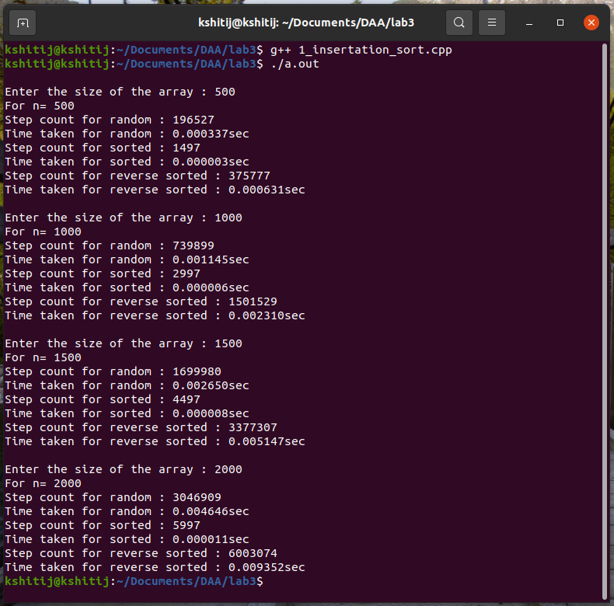

**Q2)** Write a program to compute the nth Magic number (recursively) defined as below and find its time complexity (in terms of number of recursions).nth magic number MN(n) = MN(n-1) + MN(n-2), whereas MN(0) = 0, and MN(1) = 1.

Program:

/*

Written By: Kshitij Kumar Sharma Roll No: 1905514

Question:

Write a program to compute the nth Magic number (recursively) defined as below and find its time complexity (in terms of number of recursions).nth magic number MN(n) = MN(n-1) + MN(n-2), whereas MN(0) = 0, and MN(1) = 1.

Idea of the solution:

I am defining a fibo function for calculating the n th fibonachi series number recursively, and then applying the divide and conquer approach for finding the n th number.

*/

#include<bits/stdc++.h>

using namespace std;

int t=0; //Variable for keeping no. of recursions

int fibo(int n,int a,int b,int c) //function for calculating the nth fibonachi number.

{

t++;

if(n==0)

return a;

if(n==1)

return b;

if(n==2) //break condition of the recursion

return c;

a=b;

b=c;

c=a+b;

n--;

fibo(n,a,b,c); //recursively calling the fibo function with the updated value

}

int main()

{

int n,mn;

cout<<"Enter the position of the magic no : ";

cin>>n; //taking the n th number from user

if(n>=2)

mn=fibo(n-1,0,1,1)+fibo(n-2,0,1,1); //applying divide and conquer

cout<<"The magic no. is : "<<mn<<endl;

cout<<"No. of recursions : "<<t<<endl;

}

Output:

